# xpedx.com Next generation

# *Request Forms Design Document*

**Authors: Sterling Commerce**

**Date Created:** 04/12/10

**Last Updated:** 8/26/2010 8:54 AM

**File Name:** C:\Documents and Settings\bfurman\My Documents\Temp\Methodology v1.1\Project Management\TEMPLATE - DOCUMENT - Use Case Definition.docxpedx Request Forms Detail Design Doc V1.3.docx

Approval Signatures (Mandatory)

|  |  |  |  |  |
| --- | --- | --- | --- | --- |
| **Title** | **Name** | **Signature** | **Date** | **Comments / Issues / Concerns** |
| **xpedx Owner(s)** | Steve Bugher |  |  |  |
| Cheryl Tullis |  |  |  |
| **Sterling Commerce Owner(s)** | Guy Read |  |  |  |
|  |  |  |  |

**Note**: The sign off indicates approval of all sections of the document.

Document Revision History

This chart tracks the changes introduced by the revisions to the document as the project progresses through the stages of the System Development Life Cycle (SDLC).

| Version | **Date** | **Description (Changes Made)** | **Author(s)** |
| --- | --- | --- | --- |
| 0.1 | 04/12/2010 | Initial Draft | Sterling |
| 1.0 | 04/16/2010 | Ready to deliver | Sterling |
| 1.1 | 06/16/2010 | Updates based on feedback dated 20100614 and subsequent meetings. | Sterling |
| 1.0 | 7/29/2010 | Added sections on Return Request form. Renamed document to Request Forms | Sterling |
| 1.1 | 8/10/2010 | Updated with Contact us form information | Sterling |
| 1.2 | 8/18/2010 | Updated with decisions/answers from meeting 8/18 | Sterling |
| 1.3 | 8/26/2010 | Updated with feedback from meeting 8/26 | Sterling |

Related or Reference Documents

| Document Name | Description | Owner | Location |
| --- | --- | --- | --- |
| SCI_Xpedx Solution Definition Document v1.5 | Solution Definition document | Sterling Commerce |  |
| Samples v1.4.pdf | UI Screenshots for samples | Xpedx/IW/Sterling Commerce |  |

TABLE OF CONTENTS

1 Introduction 6

Document Purpose 6

Document Audience 6

2 Sample Requests 7

Functions & Solution 7

2.1.1 Sample Requests 7

2.1.2 Sample Request Business Rules/Routing 7

2.1.3 Structure of a Sample Request 8

Sample Request Screens 9

2.1.4 New Sample Request Page 9

2.1.5 New Sample Request Lightbox 10

2.1.6 Email format for Sample Request 10

Master System 11

Implementation Details 11

2.1.7 Entity objects. 11

2.1.8 Actions involved and Functions 11

Process Flow 11

Screen Shot 12

Open Questions 13

Assumptions 13

3 Return Requests 14

Functions & Solution 14

3.1.1 Return Requests 14

3.1.2 Structure of a Return Request 14

Return Request Screens 14

3.1.3 Return Request Page 15

Master System 15

Implementation Details 15

3.1.4 Entity objects. 15

3.1.5 Actions involved and Functions 15

Process Flow 15

Screen Shot 16

Open Questions 17

Assumptions 17

4 Contact Us Form 18

Functions & Solution 18

4.1.1 Contact Form 18

4.1.2 Contact Us Page 18

Master System 19

Implementation Details 19

4.1.3 Entity objects. 19

4.1.4 Actions involved and Functions 19

Process Flow 19

Screen Shot 20

Open Questions 23

Assumptions 23

5 Glossary of Terms 24

ss

# Introduction

## Document Purpose

This document is the governing functional design document for the Sample Requests and Return Request functionality. It presents significant decisions and constructs used in developing the functionality. Testing, builds, configuration management are not covered in this document.

The document will also serve the purpose of keeping a list of assumptions that were made during design discussions.

## Document Audience

This document is intended for management and technical staff working on this project, xpedx IT and Business, webMethods, Legacy(MAX and ACCESS), HP, IW, xpedx/IP Network Team. Sterling will use the document during design and configuration for design consideration.

# Sample Requests

## Functions & Solution

Sample Requests are a way for xpedx to request for samples of item(s) that they may want to try out before buying.

A few different ways are used to capture/manage sample requests.

1. ***Paper*** – The sample requests are managed by a 3rd party tool called the Sample Application Manager (SAM).
2. ***Non-Paper (Facility Supplies, etc.)*** – The sample requests are simple forms that the customer fills out on the web and an email is sent out to the division’s CSR.

Return Requests are a way for customer users to request returns on line items of an order that has already been placed

## Sample Requests

For Paper type samples, there are Sample Centers around the country and they have divisions associated to them. Based on the division to which a customer is associated to, the sample request is routed to the appropriate Sample Center. This routing logic will not be implemented in Sterling for BR1.

For BR1 – Sterling will implement a simple form based sample request for all types of samples.

There are two launch points for requesting samples.

1. From an item detail page – link called “request sample”
2. From the home page via the ‘Services’ tab

There is no flag today to identify the items that may be sampled or not. Hence samples of all items may be requested, depending on whether a customer has been enabled for samples . However, this does not guarantee that a sample will be sent to the customer.

For the majority of the cases, samples are requested one item at a time. Hence, it would be useful to have the item/customer information pre-populated in the Sample Request form when the “request sample” link is clicked from within an item.

Once a sample request is submitted, Sterling converts it to an email and sends the email to the recipients specified below.

## Sample Request Business Rules/Routing

Customer Profile flag – Service Optimization Code – categorizes customers into

K – Key

P – Preferred

Q – Quality

V – Value

By default, the ability to request samples will be turned off for “Value” and “Quality” customers.

Two new fields will be added -

1. Customer Profile – Can Request Sample – Yes or No. Defaults to Yes or No depending on the logic specified above.
2. Division Profile - Sample form target email ids – one for paper and one for non-paper requests. A list of email addresses that will receive the sample form when it is submitted.

If a sample request contains a paper sample or general sample, then the e-mail addresses associated for samples on the Ordering division profile should receive a copy of the Sample Request via e-mail. There will be 2 separate e-mail ID’s for samples: one for Paper, and one for General. The Paper E-mail ID will have the address for the Sampling Center for that Division. The General E-mail ID will have the e-mail address(es) for the CSRs for that division. (could be a group inbox for the CSRs).

The first Sales Rep and CSR associated with the customer account should always be copied on the Sample E-mails. A copy of the Sample request should always be sent to the customer.

## Structure of a Sample Request

Sample requests have the following fields

1. Header Information
   1. Notes
   2. Fedex/UPS (choice)
   3. Fedex/UPS Account Number
2. Customer Information
   1. Account Number
   2. Customer Name
   3. Customer Contact Name
   4. Contact Phone Number
   5. Shipping Address 1/2/3
   6. City/Sate/Zip/Country
   7. Email address
3. Company/Division Information
   1. Division Number/Name associated to customer account
   2. Sales Representative 1 – tied to the customer account.
   3. CSR (from Customer profile eCSR1)
4. Item Information – Multiple Lines
   1. Manufacturer
   2. Manufacturer Part Number
   3. Item description (non-Paper)
   4. Grade (paper only)
   5. Weight (paper only)
   6. Color (paper only)
   7. Finish (paper only)
   8. Size (paper only)
   9. Quantity

Fields that must be required field(s) on the Request sample page before the user clicks on either the ‘Add to List’ or ‘Submit request’ button?

* For ‘General’ tab on the original ‘Request Sample’ form, the following fields are required fields to successfully ‘Add’ the items to the list.

1. Mfg SKU
2. Mfg
3. Description

* For ‘Paper’ tab on the original ‘Request Sample’ form, the following fields are required fields to successfully ‘Add’ the items to the list.

1. Grade
2. Weight
3. Color
4. Size
5. Qty

* In order to successfully ‘Submit’ the request, the following information must be entered or populated:

1. Contact
2. Address 1
3. City
4. State/Province
5. Zip Code
6. Country
7. Phone
8. E-Mail
9. FedEx/UPS # (if FedEx or UPS is selected)
10. At least on item should be added in the list

Add an additional radio button to the right of ‘UPS’ radio button. As a default, ‘None’ will be selected.

## Sample Request Screens

The list of all pages related to Sample Requests

1. New Sample Request Page
2. New Sample Request Lightbox

## New Sample Request Page

This page displays the customer/company info prepopulated. It has a fixed number of lines (10) to enter in the item information fields that are listed in 2.1.2. So a customer can request a maximum of 10 item samples per form.

Note: If the user navigates away from this page, the information that the user entered/selected (e.g. item info) will be lost. Sterling will not store any of the fields on a sample request. This will be conveyed clearly to the user via messaging based on the UI design.

Pre-populated fields –

1. Customer Information
2. Company/Division Information

Customer entered fields

1. Header Information
2. Item Information

Actions – The following actions are permitted on this page

1. Edit the Customer Information
2. Edit the Company/Division Information
3. Edit the Header Information
4. Edit Item Information
5. Submit the sample request
6. Cancel the sample request

## New Sample Request Lightbox

This light box is used to request a sample for a single item. A user arrives on this light box by clicking the “request sample” link from an item detail page. Once the link is clicked, the user is presented with a form that has many of the elements prepopulated. The user then has the opportunity to edit some of the details and submit the request.

Pre-populated fields –

1. Customer Information
2. Company/Division Information

Customer entered fields

1. Header Information

Actions – The following actions are permitted on this page

1. Edit the Customer Information
2. Edit the Company/Division Information
3. Edit the Header Information
4. Submit the sample request
5. Cancel the sample request

## Email format for Sample Request

**Sample E-mail Request (to internal users and customers)**

**Online Sample Request for MetroGraphics**

|  |  |  |  |
| --- | --- | --- | --- |
| Request Date: | 06-21-2010 | Account #: | 1234-5678-0000 K |
| Sales Rep: | Don Smith |  |  |
| Division: | xpedx – Cincinnati |  |  |
| Brand | Xpedx | CSR: | Claire Hurley |

|  |  |  |  |  |  |
| --- | --- | --- | --- | --- | --- |
| **Requestor Information** | | | | **Recipient Information** | |
| Requestor: | Andrew Bernard | | | Name: | Jim Halpert |
| Username: | Abernard | | | Phone: | 555-555-5555 |
| Phone: | 555-555-55555 | | | E-mail: | jhalpert@designs-r-us.com |
| E-mail: | a.bernard@metrographics.com | | | Ship To: | 1234 Main St.  Cincinnati, OH 12345  United States |
|  |  | | |
|  |  | | |
|  |  | | |
| Expedite Shipping? | | No |
| Ship Via: | | FedEx |
| Shipping Code: | | 1254789654 |

**Sample Details**

**General Products**

|  |  |  |  |  |
| --- | --- | --- | --- | --- |
| **Product Type** | **Mfg SKU** | **Mfg/Mill** | **Description** | **Qty** |
| General | 123456789 | 3M | Roll of Tape | 1 |
| General | 487965 | P&G | Need to sample the new Windex | 1 |

**Paper Products**

|  |  |  |  |  |
| --- | --- | --- | --- | --- |
| **Product Type** | **Mfg SKU** | **Mfg/Mill** | **Description** | **Qty** |
| Paper | 14587965478 | Mohawk | Beckett Cambric, 24 Pt, White, Linen, 8.5” x 11” | 15 |

**Special Notes:**

Lorem ipsum dolor sit amet, consectetur adipiscing elit. Duis imperdiet nibh at nisl sagittis malesuada. Ut interdum imperdiet metus ac pretium. Maecenas eu massa ac lacus sagittis faucibus. Aenean mauris urna, ullamcorper nec vestibulum et, tincidunt non elit. Duis pellentesque arcu mi. Sed facilisis ullamcorper dui, sit amet vehicula lorem adipiscing a. Suspendisse ut nisi leo, id venenatis tellus. Vestibulum ante ipsum primis in faucibus orci luctus et ultrices posuere cubilia Curae

Clarifications -

Account Type – Sent the first letter of the K/P/Q/V. If any other value is found, send “O”

Requestor Information – From user profile of the customer user who is logged in.

Recipient Information – From the “Ship to” fields of the Samples form.

Note: We need to separate out the paper products and non-paper products into separate tables in the same email. The exact same email is sent to all the target parties (internal users and customer users).

## Master System

N/A – No samples related information is stored in Sterling.

## Implementation Details

## Entity objects.

## Actions involved and Functions

## Process Flow

## Screen Shot

The screen shots pasted here are still in review and not final. This is just an illustration of how it looks today.

***Request Sample Page***



## Open Questions

1. Per the business requirements for BR1 we were going to manage all samples in SAM and Sterling would provide a link to the application. This has changed – I would like to confirm the change in requirements. [Steve B. 20100426 - BR 1 will include a web form for the type of Sample Request. Paper Sample form example attached below]
2. Which email address is the sample request email sent to? [Cheryl T. - ? Sample form target email IDs, see 1.1.2.] [Prashant – 20100616 – Didn’t find anything in the feedback relating to the email].[Prashant – 8/18 – clarified recipients of sample email form. Detailed in 2.1.2]
3. UI templates for
   * Sample Create Request
   * Multiple lines in a sample request form
   * Email template where the samples request is submitted to.
4. Can only customers request samples? [ Steve B – 20100426 – Yes.]
5. On the Saalfeld form there are no notes, item qty or item uom. Do we need these? [Steve 8/18 – Yes. Been merged together]
6. Do we need to support Shipping Method ? [Steve B. – 20100426 - not for Saalfed web form ,but for Print web form, we do]. [Steve – 8/18 – Same form for both]
7. [Steve B. – 20100426 - Are we saying a user can only add one item to a Sample request from the Catalog? I.e. Once they add the item, they must either manually add items or submit the Sample Request] [ Prashant – 20100616 – Yes. Based on meeting 6/14, the single item request will be handled via the lightbox while multiple items will be handled through the samples page. This goes back to our discussion of not having to build a cart like functionality just for samples]
8. There was going to be just one web form - Not storefront or brand specific. So the Saalfeld form will have these fields, but they will be ignored by the person receiving the request, right ? [George/Steve 20100615 - Same set of fields not different by segment or brand]
9. [Prashant 7/28 – How do we determine whether a product is paper or not, if the “request sample” link is clicked from the item details?].[George – 8/18 – Use the first Category 1 of the Item, if there are multiple categories that an item is assigned to.]
10. [Prashant 7/28 – based on answer to Q9, do we need to pre-populate manufacturer/mill or is this a user entered value even on the item detail request sample page ?]. [No need to pre-populate attribute data.]
11. [Prashant 7/28 – Which CSR/Sales Rep information is populated in the email output?]. [Steve -8/18 – Get CSR/Sales Rep From the Customer profile.]
12. Once the user clicks on the ‘Submit Request’ button, what page should return after this? Should they receive a confirmation page stating their sample request has been successfully submitted or will they be returned to the ‘Service’ landing page.  (I assume for the lightbox, it will return them to Item Detail page.)  They should receive a message that the Sample Request has been received.  From there I’d expect the sample request page to be re-loaded but will be empty.  Your other assumption is correct about the Item Detail page.

## Assumptions

1. Tracking of sample requests is out of scope for BR1
2. Approval workflows for samples is out of scope for BR1
3. Long term management and tracking of samples is out of scope for BR1
4. xpedx will provide the final screenshots for the pages listed in the screen shots section. Currently we’re using the existing dotcom pages as placeholders to capture the key data elements.
5. Each sample request is a simple form. If a user navigates away from the form, the data entered on that form is lost; i.e., it doesn’t function like a cart where you can go back and keep adding items to the same cart.

ss

# Return Requests

## Functions & Solution

Return Requests are a way for customer users to request returns on line items of an order that has already been placed and is in any status after shipped (including shipped).

## Return Requests

The solution for BR1 for returns is a form that captures the details of the items/quantities that are being returned and sends out an email to the CSR email address that is stored on the ordering division profile. A copy is also sent to the customer.

This form is access from the order history page. If the order is in any status higher than and including shipped, then a Request Return link shows on the page. This happens only at the fulfillment order level.

On clicking the link, the user is shown a page with the items from the fulfillment order along with input fields such as requested return quantity, reason for return.

After entering the requested return qtys, etc, the user submits the form and a copy of the email is sent to the user as well as the csr email address on the ordering division profile.

## Structure of a Return Request

Return requests have the following fields

1. Header Information (all mandatory unless otherwise noted)
   1. Account Number
   2. Web Confirmation #
   3. Order Number
   4. Requested by
   5. Username
   6. Phone
   7. Email
   8. Notes (not mandatory)
2. Item Return Information – Multiple Lines
   1. Item sku
   2. Item Image
   3. Item Description
   4. Quantity Ordered
   5. Quantity to be returned
   6. UoM
   7. Reason for return
   8. Reason Note (only in case the Reason for return is “Other”).

## Return Request Screens

The list of all pages related to Return Requests

1. Return Request Page

## Return Request Page

This page displays the order information pre-populated along with certain fields that the customer user needs to provide to complete the request.

Note: If the user navigates away from this page, the information that the user entered/selected will be lost. Sterling will not store any of the fields on a return request.

Pre-populated fields that cannot be edited by user –

1. All header information other than Phone/Email and Notes.
2. All Item Return information other than Qty to return and Reason for return.

Actions – The following actions are permitted on this page

1. Remove Lines
2. Submit Return Request
3. Cancel the Return request

## Master System

N/A – No returns related information is stored in Sterling.

## Implementation Details

## Entity objects.

## Actions involved and Functions

## Process Flow

## Screen Shot

The screen shots pasted here are still in review and not final.

***Return Request Page***

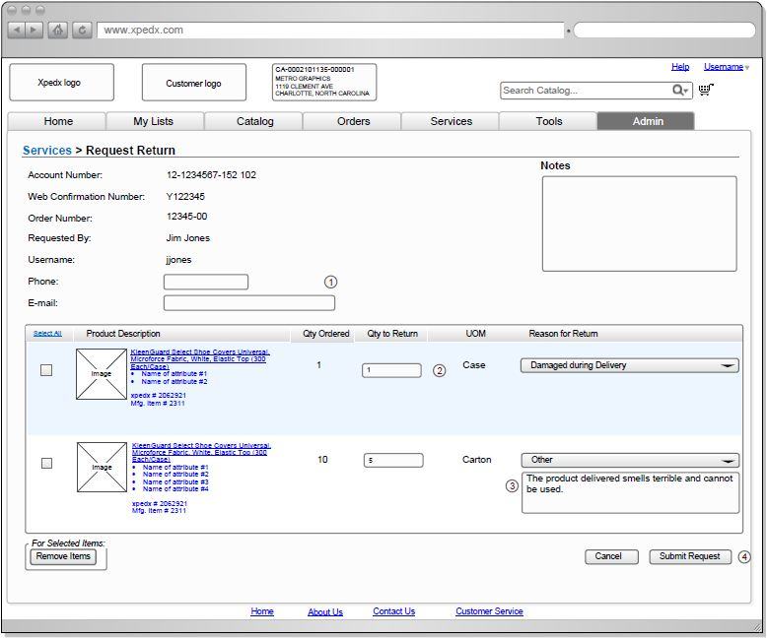

## Open Questions

1. Need the Email format for return request
2. Once the user clicks on the ‘Submit’ button, what page should return after this? Should they receive a confirmation page stating their request has been successfully submitted or will they be returned to the ‘Return Request’ page. Ans -  They should receive a message that the Request has been received.  From there I’d expect the Return Request page to be re-loaded but will be empty.

## Assumptions

1. Tracking of return requests is out of scope for BR1
2. Each return request is a simple form. If a user navigates away from the form, the data entered on that form is lost
3. The return requested qty should be lesser than or equal to the ordered quantity.

# Contact Us Forms

## Functions & Solution

The contact us forms are a way for xpedx customers to contact xpedx with any query that they may have. This page provides contact information of sales reps/CSRs/divisions, if available. It also provides a form to send an email to xpedx.

## Contact Form

The solution for BR1 for contact us form has two flavors

1. Contact us form for a customer users that are logged in.
2. Contact us form for an anonymous user.

This main difference between the two forms is that the logged in user form has detailed information specific to their ship to as well as access to contact information of their assigned Sales Reps and CSRs. The anonymous user contact form contains generic contact information.

The forms are access from the footer links. If the user chooses to send the query by email a copy of the email is sent to the user in addition to xpedx.

## Contact Us Page

The contact us page for the logged in customer user has the following sections

Contact Information – This section contains the following information

1. Local Division Profile Information - Ordering division tied to Bill to of the Ship to.
   1. Division Address
   2. Division Phone
   3. Order Cutoff Time
2. Sales Rep Profile Information – The sales reps tied to the customer from the customer batch.
   1. Sales Rep Name
   2. Sales Rep Phone
   3. Sales Rep Email id
3. Customer Service Rep Information – From eCSR1 & 2 fields on the Customer Profile. In case there are none on the customer profile, find them on the division profile.
   1. CSR Name
   2. CSR Phone
   3. CSR Email id

Email Contact Request – This section contains a form that the user may fill up and submit. It results in an email being sent to xpedx and a copy to the user.

Email Contact Requests have the following fields -

1. First Name
2. Last Name
3. Phone
4. Email
5. Order #
6. Subject (drop down)
7. Questions/Comments

For BR1 – the contact us form for the logged in user and anonymous user is not driven by the subject. They are both routed to one email address.

In the case of logged in user the email is routed to send form to email id of the CSR1 field on customer profile. If empty the emails is sent to the divisions’ csr email address field.

In the case of anonymous users, the email is routed to eBusiness support – [ebusiness@xpedx.com](mailto:ebusiness@xpedx.com)

Note: If the user navigates away from this page without submitting it, the information that the user entered/selected will be lost. Sterling will not store any of the fields on a email contact request.

Actions – The following actions are permitted on this page

1. Clear the email contact form
2. Submit Email Contact Request

## Master System

N/A – No email contact us request information is stored in Sterling.

## Implementation Details

## Entity objects.

## Actions involved and Functions

## Process Flow

## Screen Shot

The screen shots pasted here are still in review and not final.

***Contact Us Page (Customer User)***

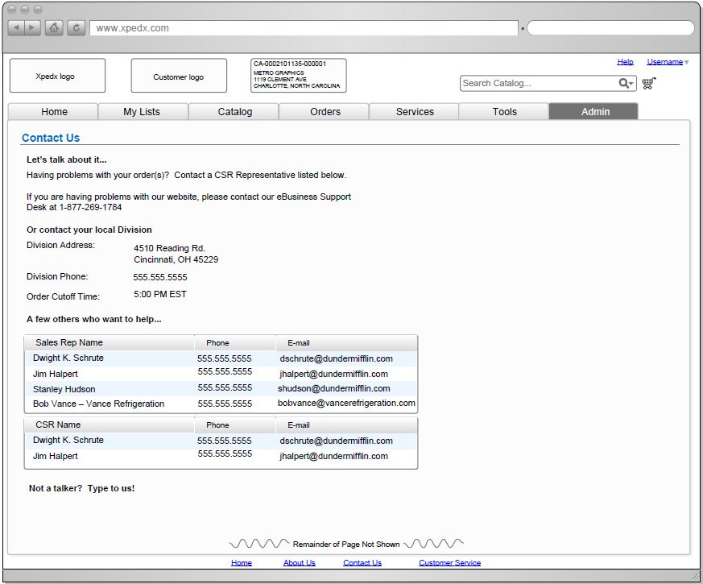

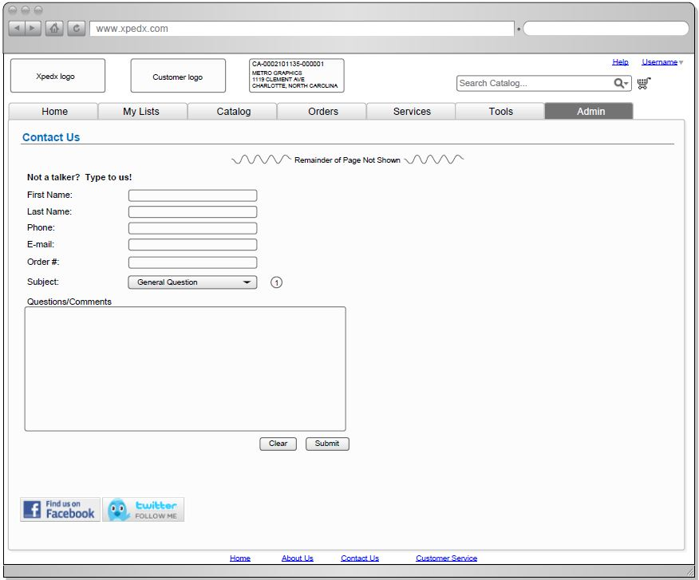

***Contact Us Page (Anonymous User)***

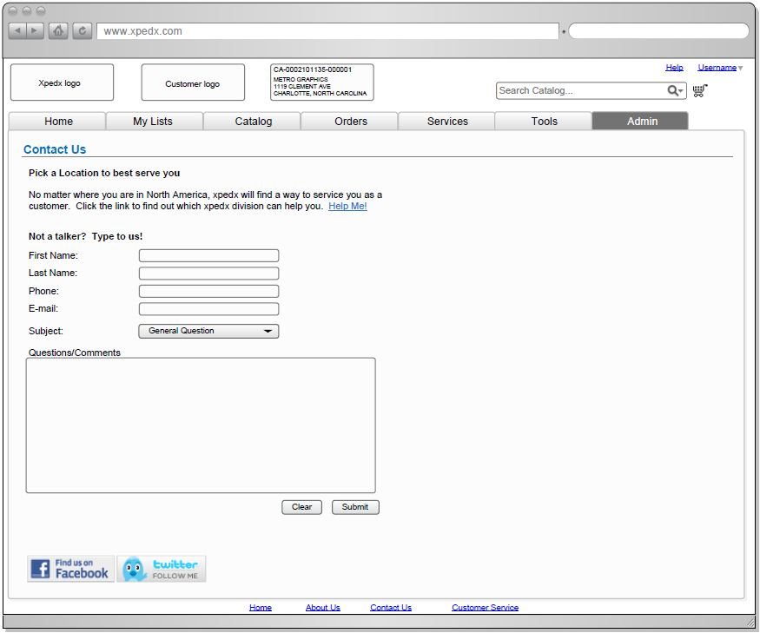

## Open Questions

1. Which divisions contact information is displayed? Customer Division? Ship From Division? Ordering Division (bill to) ? [Chris - 8/11 - This should be from the Customer Division (Bill To).] [PG - 8/11 - "Customer Division" is a field at the ship-to level. "Ordering Division" is at the Bill-To level. So which one are we saying we need to use ?][George – 8/13 – Customer Division present on the Ship-To record. Part of the Account number also]
2. The email section comments talk about sending email to different recipients based on “subject” selected. Please provide a list of all subjects and corresponding recipients. [Chris – 8/11 - xpedx to provide this list.][Steve – 8/18 – Not for BR1. For now it’s a form sent to one address not tied to subject.][Prashant 8/18 – routing logic included in section 4.1.2.]
3. Links to "facebook" and "twitter follow me" - what are these about ? [Chris – 8/11 - These are links to xpedx’s Twitter and Facebook account. These will be hard coded links.] [Chris - 8/13 - Facebook: http://facebook.com/xpedx Twitter: http://twitter.com/xpedx]
4. "Help me" link that seems to suggest some sort of division search/selection page. Where are the screenshots for this? Also this seems to be creating some scope, since anonymous user was supposed to be a fairly straightforward form for contact us. [Chris – 8/11 - This is a hard coded link to the “Locations” page on the xpedx marketing site.] [Chris - 8/13 - http://xpedx.com/Locations/default.aspx]
5. What are the routing requirements of the anonymous contact usform ? Does it need to be emailed to the user as well as the csrs? Etc. [Chris – 8/11 - Email should go to [ebusiness@xpedx.com](mailto:ebusiness@xpedx.com) (or [ebusiness@brandname.com](mailto:ebusiness@brandname.com), or distribution.ipaper.com – these all go to same place)]. [Prashant – 8/18 – Routing requirements based on decisions made today in section 4.1.2.]
6. Once the user clicks on the ‘Submit’ button, what page should return after this? Should they receive a confirmation page stating their request has been successfully submitted or will they be returned to the ‘Contact Us’ page. Ans -  They should receive a message that the Request has been received.  From there I’d expect the Contact Us page to be re-loaded but will be empty.

## Assumptions

1. Each email contact request is a simple form. If a user navigates away from the form, the data entered on that form is lost.

# Glossary of Terms

|  |  |  |
| --- | --- | --- |
| S. No. | Term | Definition |
| 1. | Content Server | A server that hosts all the collateral such as images, specification sheets, etc. |
| 2. | BR1 | Business Release 1 |
| 3. | IW | Industrial Wisdom – UI firm engaged on the project. |
|  |  |  |